IMAGE AND VIDEO PROCESSING
3. Image Segmentation
3.1 Segmentation based on Discontinuities (point, Line, Edge).
3.2 Image Edge detection using Robert, Sobel, Prewitt masks, Image Edge detection using Laplacian Mask.
3.3 Region Oriented Segmentation: Region growing by pixel Aggregation, Split and Merge
PAST QUESTIONS:
- Perform segmentation using split-and-merge technique on the following image. Show the quad-tree representation.
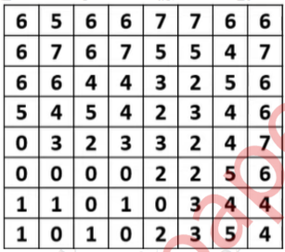

- Explain split & merge method to find region similarity.
For the following given image, find a homogeneous region using the following Criteria max[f(x,y)]-min[f(x,y)]<=3
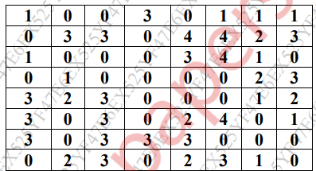
- Explain the working of Canny edge detector.
- Short note on Image Segmentation.
- Write derivation for Prewitt Edge detection operator. What is the advantage of a Prewitt operator? Compare Sobel & Prewitt edge operator.
- Explain edge detection using Sobel and Prewitt mask.
NOTES:

*Image Segmentation :-
Image segmentation is a fundamental technique in digital image processing and computer vision. It involves partitioning a digital image into multiple segments (regions or objects) to simplify and analyze an image by separating it into meaningful components, which makes the image processing more efficient by focusing on specific regions of interest. A typical image segmentation task goes through the following steps:
- Groups pixels in an image based on shared characteristics like colour, intensity, or texture.
- Assigns a label to each pixel, indicating its belonging to a specific segment or object.
- The resulting output is a segmented image, often visualized as a mask or overlay highlighting the different segments.

*Edge Detection :-
Edge detection is a technique used to identify the boundaries of objects within images. It helps in simplifying the image data by reducing the amount of information to be processed while preserving the structural properties of the image.
Common Edge Detection techniques:
- Sobel Edge Operator - The Sobel operator is a discrete differentiation operator used in image processing and computer vision for edge detection. It detects edges by calculating the gradient of image intensity at each pixel.
It uses two 3x3 convolution kernels to calculate the gradient in the horizontal and vertical directions.
The Sobel operator is a first-order derivative filter used in image processing to detect edges.
It combines:
- Differentiation for edge detection.
- Smoothing to reduce the effect of noise.
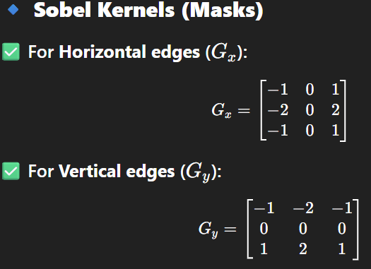
Applications –
- Object boundary detection
- Road lane detection in self-driving cars
- Feature extraction in AI models
- Medical image edge detection
- Prewitt Edge Operator - The Prewitt operator is a simple spatial filter used for edge detection by approximating the image gradient. It highlights areas where the intensity changes sharply, which correspond to edges in the image.
It is a type of first-order derivative operator that calculates the gradient in the horizontal and vertical directions.
It uses two 3×3 convolution kernels (masks) to estimate the gradient components:
  - G_{x}: Measures change in intensity in the horizontal (x) direction.
  - G_{y}: Measures change in intensity in the vertical (y) direction.
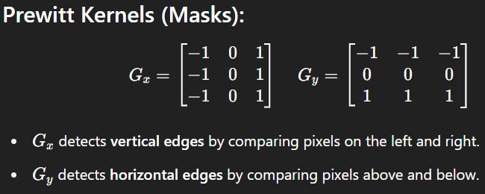
Applications –
- Object boundary detection
- Road lane detection in self-driving cars
- Feature extraction in AI models
- Medical image edge detection
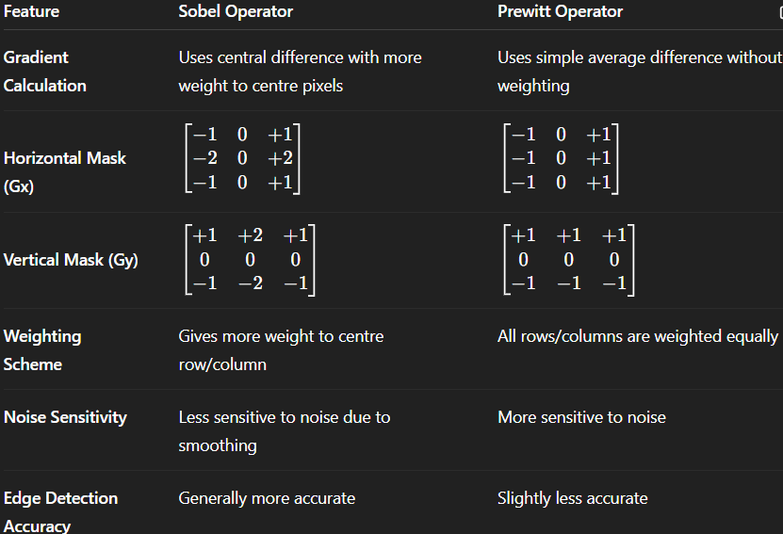
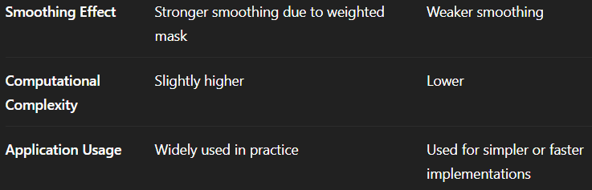

* Split and Merge :-
Split and Merge is a region-based segmentation technique used to divide an image into homogeneous regions based on some criteria.
It follows a top-down (split) and bottom-up (merge) approach to identify uniform regions.
1. Splitting Phase:
- The image is recursively split into quadrants (like a quadtree structure).
- A region is split if it does not satisfy a homogeneity criterion (e.g., all pixels are not similar).
- This continues until all sub-regions are homogeneous or the region cannot be divided further (e.g., 1×1 pixels).
2. Merging Phase:
- After splitting, adjacent regions are compared.
- If two or more neighbouring regions together satisfy the homogeneity condition, they are merged.
- This step reduces over-segmentation caused by excessive splitting.
Key concept –
- Quadtree - A data structure that recursively splits the image into four equal blocks.
- Region - A block or area in the image being tested for homogeneity.
- Homogeneity - A property indicating similarity in pixel values (e.g., mean, variance).

